**Proposed Modelling Approach**

Example sketch of statistic vs date, where the colors represent different policies in a policy category:

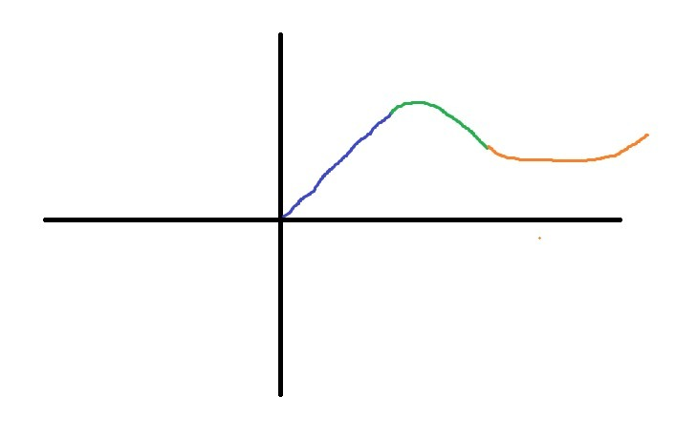

* x-axis: date
* y-axis: covid statistic
* Colors: policies within a policy category

Example Details:

* y-axis: Daily Confirmed COVID Cases
* x-axis: Time (Dates)
* Category:
  + School Closing
* Policies:
  + Blue: No policy
  + Green: Mandatory school closing
  + Orange: Only public schools closed

Example Approach:

* Do a **simple linear regression** for each policy (color) to find the relation at each policy
  + Let’s say we find the relations to be:
    - y = 1.5*x → blue policy
    - y = -0.5*x2 → green policy
    - y = 0.2*x2 → orange policy
* Based on the above equations, we would conclude that the **green policy is the most effective** as its correlated with the lowest slope (derivative) of Daily Confirmed COVID Cases
  + I.e. correlated with a decrease in Daily Confirmed COVID Cases
  + We would also conclude that the **orange policy is worse than green**, and that the **blue policy is worse than orange**
* **Do this for all states and compare the results** 
  + See if the green policy (or something similar) is consistently the best

We would do the above process for different policy categories and COVID statistics (such as daily deaths, hospitalization rate, mortality rate, etc.)